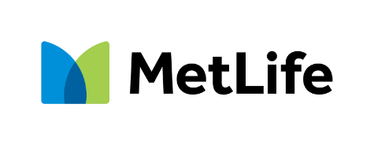
It’s your future.
Start saving for it now.
[Dear First Name Last Name],
As a current participant in your company-sponsored retirement plan, you’ve already taken a big step towards saving for your financial future.[ Click here to see additional steps you can take today, to have the retirement you want for tomorrow.][ Click here to see additional steps you can take today, to have the retirement you want for tomorrow.] [Click here to see additional steps you can take today, to have the retirement you want for tomorrow.]
Did you know?
The median retirement income for adults 65 and older is $50,000.¹ | 55% of Americans worry they won’t be financially secure when they retire.² | $40,000 is the median annual spending for retirees.¹
Don’t wait. Save today!
[You’ll need your plan number to get started: [PLAN NUMBER]]
[If you are considering increasing your contributions today complete this Salary Deferral Application and submit it to your HR.
OR
If you are considering increasing your contributions today visit mlr.metlife.com. Go to the Account tab, choose “My Contributions” and click on edit to update your selections.
OR
If you are considering increasing your contributions today reach out to your HR to obtain your plan specific forms to complete this change.]

Access your account – anytime from any device.
Log in or register at online.metlife.com
Watch this video to see how simple it is to manage your account online with MyAccounts

¹ U.S. Bureau of Labor Statistics (2023). "2022 Consumer Expenditure Survey." and “HINC-01. Selected Characteristics of Households by Total Money Income.”
² National Institute on Retirement Security (2024). “Retirement Insecurity 2024: Americans’ Views of Retirement.”

If you do not wish to receive commercial emails from MetLife or its affiliates in the future, click here or email your request to dnss@metlife.com. Do not respond to this email to opt-out. You may also contact us in writing at MetLife Customer Privacy Center, P. O. Box 489, Warwick, Rhode Island 02887-9954. Please allow up to 10 days for us to process your opt-out. You may receive emails from us during that time, for which we apologize. If you are eligible for benefits through an employer that offers benefits provided by a MetLife company, this opt-out will not apply to emails relating to those benefits.

Metropolitan Life Insurance Company | 200 Park Avenue | New York, NY 10166
06092020C L0724041881[exp0726][All States][DC] © 2024 MetLife Services and Solutions, LLC.

